Name: Sarthak Chouhan
Roll no.: 23I4065

Lab Assignment 2: Study and Understand Ubuntu Commands
Part 1: Outputs of the Following Commands
- pwd
It prints the current working directory.
Output:
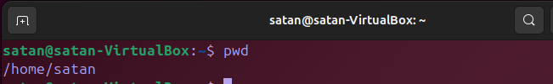

- cd
Changes the current directory.
Output:
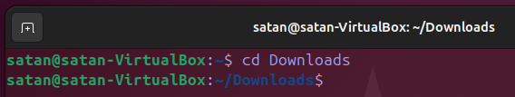

- ls
Lists files and directories in the current directory.
Output:
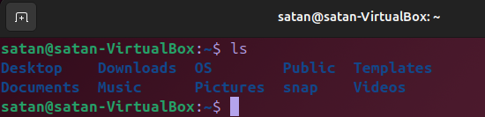

- mkdir
Creates a new directory.
Output:
- rm
Removes files or directories.
Output:
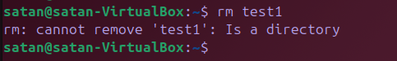

- touch
Creates an empty file or updates the timestamp of an existing file.
Output:


- hostname
Displays the system's hostname.
Output:


- cat
Displays the contents of a file.
Output:


- chmod
Changes file permissions.
Output:
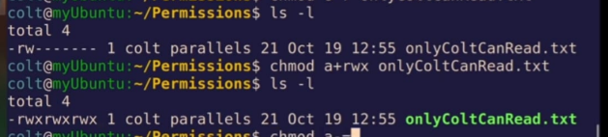

- echo
Displays a line of text or a variable's value.
Output:

- grep
Searches for a pattern in a file.
Output:
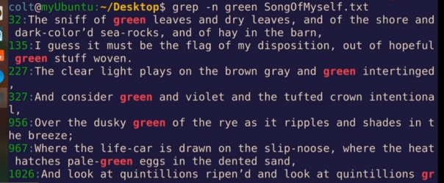

- fgrep
Searches for fixed strings in a file.
Output:
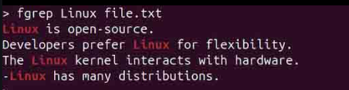
- mv
Moves or renames files/directories.
Output:
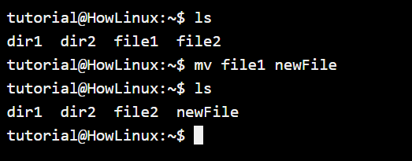

- cp
Copies files/directories.
Output:
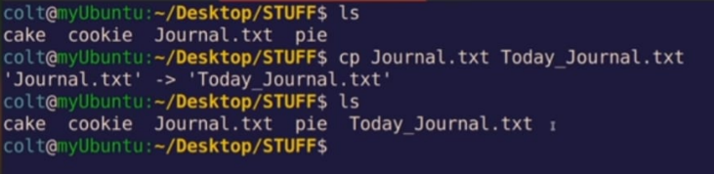

- more
Displays file content one screen at a time.
Output:
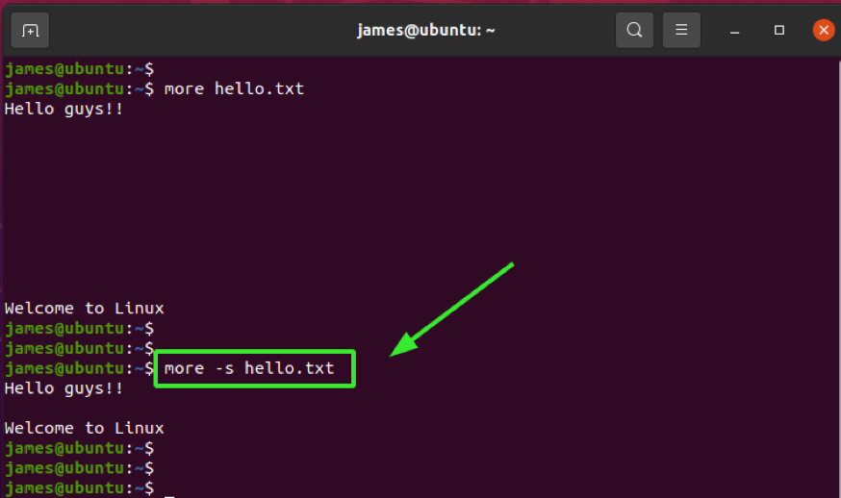

- less
Displays file content with backward navigation.
Output:
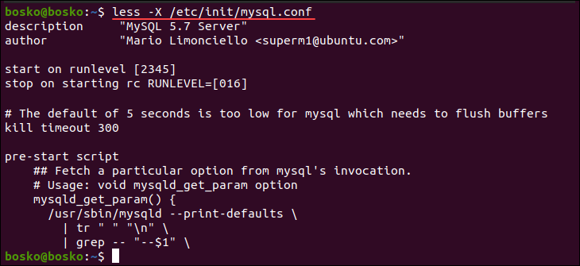

- wc
Counts lines, words, and characters in a file.
Output:

- awk
Processes and analyzes text files.
Output:
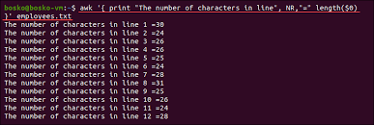

- sed
Stream editor for filtering and transforming text.
Output:
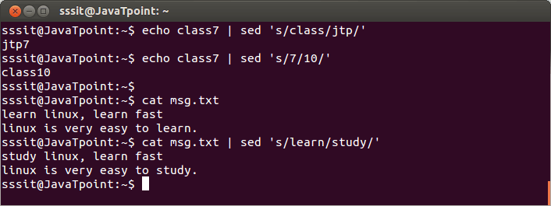

- tail
Displays the last part of a file.
Output:
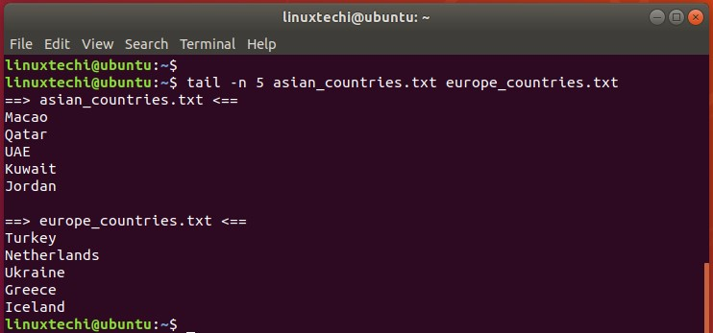

Part 2: Answers to the Following Questions

- How to navigate to a Specific Directory?
Ans- We use the cd command followed with the specific location.
Example:
cd /path/to/directory

- How to see detailed information about files and directories using ls?

Ans-

ls -l

- How to create multiple directories in Linux using `mkdir` command?

Ans-

mkdir dir1 dir2 dir3

- How to remove multiple files at once with rm?

Ans-

rm file1 file2 file3

or for files with wildcards

rm *.txt

- Can rm be used to delete directories?
Ans- Yes, to delete directories:
rm -r directory_name

- How Do You Copy Files and Directories in Linux?

Ans-

cp source_file destination_file

cp -r source_directory destination_directory

- How to Rename a file in Linux Using mv Command

Ans- Using

mv old_filename new_filename
- How to Move Multiple files in Linux Using mv Command

Ans-

mv file1 file2 file3 /destination/directory/

- How to Create Multiple Empty Files by Using Touch Command in Linux

Ans-

touch file1 file2 file3

- How to View the Content of Multiple Files in Linux

Ans-

cat file1 file2

- How to Create a file and add content in Linux Using `cat` Command

Ans- To create a file and add content, we use:

cat > filename

then type the content and save the file.

- How to Append the Contents of One File to the End of Another File using cat command

Ans-

cat source_file >> destination_file

- How to use cat command if the file has a lot of content and can’t fit in the terminal.

Ans-

cat filename | less

- How to Merge Contents of Multiple Files Using `cat` Command

Ans-

cat file1 file2 > merged_file

- How to use cat Command to Append to an Existing File

Ans-

cat >> filename

- What is “chmod 777 “, “chmod 755” and “chmod +x “or “chmod a+x”?

Ans- chmod 777 file - Full permissions for all.

chmod 755 file - Full permissions for the owner, read & execute for others.

chmod +x file - Adds execute permission.

chmod a+x file - Adds execute permission for all users.

- How to find the number of lines that matches the given string/pattern
Ans-
grep -c "pattern" filename

- How to display the files that contains the given string/pattern.
Ans-
grep -l "pattern" *
- How to show the line number of file with the line matched.
Ans-
grep -n "pattern" filename

- How to match the lines that start with a string using grep
Ans-
grep "^string" filename

- Can the ‘sort’ command be used to sort files in descending order by default?

Ans- No, sort sorts in ascending order by default. For descending, we use:

sort -r filename

- How can I sort a file based on a specific column using the ‘sort’ command?

Ans-

sort -k2 filename

